1. Contact details
Company: |  | Address:
Contact person: |  | Telephone:
E-Mail: |  | Date:
SCHUNK customer no.: |  | SCHUNK contact:
2. Definition of the project
Please describe the project exactly.
3. Arrangement of the application
Please sketch the requested operation under specification of dimensions and mass of the separate parts.
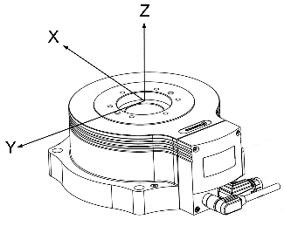
4. Requirement information (please check)
Single application |  | Technical improvement
Series, quantity per year: |  | Reduction of expenses
New construction

5. Work piece
Weight of the work piece: |  |  |  |  |  |  |  |  |  | [kg]
Distance center of gravity - center rotary flange |  |  |  |  |  |  |  |  |  | [mm] |  |  |  |  | X: |  | Y: |  |  |  |  | Z:
Resulting moment of inertia: |  |  |  |  |  |  |  |  |  | [kgm²]
6. Application data
Orientation of swivel unit: |  |  |  | vertical /  (desk mount) |  |  |  |  |  |  |  |  |  | vertical /  (roof mount) |  |  |  |  |  | horizontal /  (wall mount)
Type of application: |  | swiveling (shuttle service) |  |  |  |  |  |  |  |  |  |  |  |  |  | rotating (endless)
Swivel angle: |  |  |  |  | [°] |  |  |  |  |  |  | Maximum swivel angle: |  |  |  |  |  |  |  |  | [°]
Max. allowed swivel time  O°… x°: |  |  |  |  | [s] |  |  |  |  |  |  | Total cycle time  O°…x°…O° (incl. pause): |  |  |  |  |  |  |  |  | [s]
Number of cycles per hour: |  |  |  |  |  |  |  |  |  |  |  | Offset to start position: |  |  |  |  |  |  |  |  | [°]
External force and direction: |  |  |  |  |  |  |  |  |  |  |  | N in direction (X / Y / Z)
External torque allocated to axis: |  |  |  |  |  |  |  |  |  |  |  | Nm around axis (X / Y / Z)
Revolutions per minute n_max: |  |  |  |  |  |  |  |  | [U/min]
Angular acceleration α_max: |  |  |  |  |  |  |  |  | [rad/s²]
Repeatabilty: |  |  |  |  |  |  |  |  | [arcsec] |  |  |  |  |  |  |  |  |  | (1 arcsec = 1 / 360°)
7. Boundary conditions
Environmental  conditions | Temperature: |  |  |  |  |  | [°C]
Environmental  conditions | Humidity: |  |  |  |  | [%]
 | Dirt, interference fields, site:
Regulations | (Resources regulations,...):
Documentation | Schunk standard design  Language: German / Scale: Installation instruction, drawing(s), Bill of material Shipping method: CD-Rom with PDFs
Documentation | Special design (chargable) Definition:
Additional:

8. Swivel unit
Type |  | PRH |  |  |  |  | ERS | ERT |  |  |  |  | ERD |  |  | ERM
 |  | 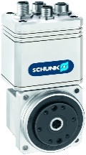 |  |  |  |  | 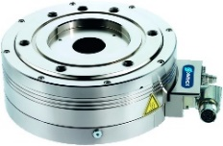 | 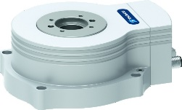 |  |  |  |  | 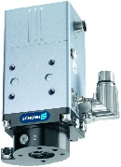 |  |  | 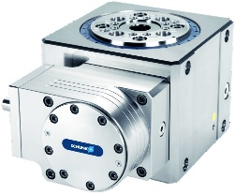
Size /  gear ratio ¹ |  |  | 50  60  75 | i = 30  i = 50  i = 100 |  |  | 135  170  210 |  | 12  50 |  | 10  300 |  |  | 04  08  12 |  | 160
Brake |  | not available |  |  |  |  | yes | yes |  |  |  |  | not available
Rotary  feedthrough |  | not available |  |  |  |  | yes |  |  |  |  |  | yes ² |  |  | standardous pneumatic feedthrough
Protection class |  |  |  |  |  |  |  | IP40 |  |  |  | IP54
Cables |  | 2m  5m |  |  | 10 m  20 m |  | 5m 10 m 15 m 20 m
Controller |  | Integrated |  |  |  |  | Bosch-Rexroth IndraDrive Cs  Others __________________ |  |  |  |  |  | Siemens S120_
9. Cycle table
Cycle  step | Swivelling angle  +/- [°] |  |  |  |  | Permitted travel time  [s] |  |  |  | Dwell time after  positioning [s] |  |  |  |  | Moment of Inertia  [kgm²]
1
2
3
4
5
6
7
8
9
10

¹ Different gear ratios are only available with PRH.
² ERD standardly has a pneumatic feed-through integrated. For the additional electric feed-through
set the check in the check box.

