1. Contact details
Company: |  | Address:
Contact person: |  | Phone:
E-Mail: |  | Date:
SCHUNK customer no: |  | SCHUNK contact:
2. Definition of the project
Please describe the task as detailed as possible.
3. Arrangement of the application
Please sketch the requested operation under specification of dimensions and mass of the separate parts.
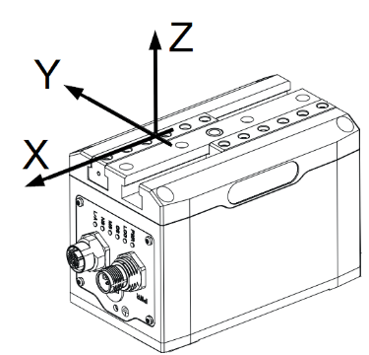
4. Requirement information (please check)
Single application |  | Technical improvement
Series, quantity per year: |  | Reduction of expenses
New construction

5. Work piece
Weight of load: |  |  |  |  |  |  | [kg]
Type of gripping: |  |  |  |  |  |  |  |  |  |  |  |  | form closure |  |  |  |  |  |  |  |  |  |  | force closure
Material of workpiece at gripping surface: |  |  |  |  |  |  |  |  |  |  |  |  | steel |  |  |  | alu |  |  |  |  |  |  | rubber |  |  |  |  | others
Clamping marks at gripping contact point allowed? |  |  |  |  |  |  |  |  |  |  |  |  | yes |  |  |  |  |  |  |  |  |  |  | no
Value of static friction (e.g.: steel on steel µ = 0,1 ): |  |  |  |  |  |  |  |  |  |  |  |  | 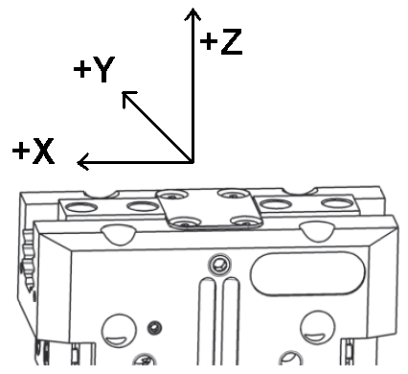
Gripping diameter / gripping measure: |  |  |  |  |  |  | [mm]
Distance center of gravity - base jaw center: |  |  |  |  |  |  | [mm] |  |  |  |  |  | X: |  |  |  |  | Y: |  |  |  |  |  |  |  | Z:
6. Gripper
Gripper type: |  |  | parallel gripper |  |  |  |  | centric gripper |  |  |  |  |  |  |  |  |  |  |  |  |  | long-stroke gripper
Customized gripper:
Gripping force maintenance: |  |  | necessary |  |  |  |  | optional |  |  |  |  |  |  |  |  |  |  |  |  |  | not necessary
Sensor: |  |  | magnetic |  |  |  |  |  |  |  |  |  |  |  |  | inductive
7. Gripping finger (optional)
Prism angle of fingers α: |  |  |  | [°] |  |  |  |  |  |  | 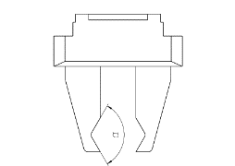  α |  |  |  |  |  |  |  |  |  |  |  | 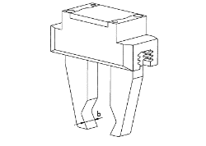  b
Prism width b: |  |  |  | [mm]
Minimal stroke per finger: |  |  |  | [mm]
Mass of each finger: |  |  |  | [kg]
Material of finger at gripping surface: |  |  |  |  | steel |  |  |  |  |  |  |  |  | alu |  |  |  |  | rubber |  |  |  |  |  |  |  | others
8. Application data
Gripper position in space |  | X axis in direction of gravital attraction |  |  |  |  |  |  |  | Y axis in direction of gravital attraction |  |  |  |  |  |  |  |  |  |  |  |  |  |  | Z axis in direction of gravital attraction
Operation data | Total cycle time (incl. dwell time) |  |  |  |  |  |  |  |  |  |  | [s]
Operation data | Gripping time |  |  |  |  |  |  |  |  |  |  | [s]
 |  |  |  |  |  |  |  |  |  |  |  |  |  |  | +/-  x direction |  |  |  |  | +/-  y direction |  |  |  |  |  |  |  | +/-  z direction
Kind of force | Acceleration of gripper |  |  |  |  |  |  |  | [m/s²]
Kind of force | Additional working force |  |  |  |  |  |  |  | [N]

9. Boundary conditions
Environment |  | Temperature: |  |  | [°C]
 |  | Humidity: |  |  | [%]
 |  | Dust, dirt, oil, cooling oils…
Regulations |  | (Resources regulations, …):
Miscellaneous:
10. Gripper
Type | EGU |  |  | EGK |  |  |  | EGP |  |  |  | EZN |  |  | ELG
 | 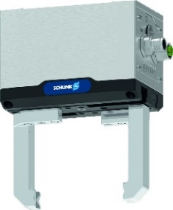 |  |  | 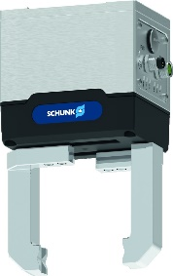 |  |  |  | 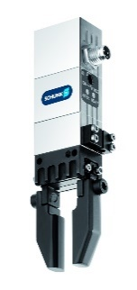 |  |  |  | 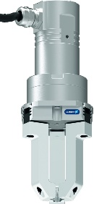 |  |  | 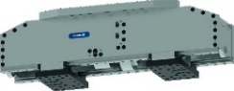
Size | 50  60 |  | 70  80 | 25  40 |  | 50 |  | 25  40 |  | 50  64 |  |  | 64  100 |  | 10  30 |  | 75  120
Communication | PROFINET  EtherCAT  Ethernet IP |  |  | IO-Link  Modbus RTU |  |  |  |  | digital I/O  IO-Link |  |  | PROFINET |  |  | Communication depends on servo drive / controller
Cables | yes, Robot: |  |  |  |  |  |  |  |  |  | 5 m  10 m |  |  | 15 m  20 m
Controller | integrated |  |  |  |  |  |  |  |  |  |  |  | ECM |  |  | Bosch  Siemens  Andere
Safety function | yes, type:
Sensors | yes, type:
Additional:

