1. Customer data
Company: |  |  |  | Adress:
Contact person: |  |  |  | Phone:
E-mail: |  |  |  | Date:
SCHUNK customer no.: |  |  |  | SCHUNK contact person:
2. Gripper version
Stroke  [in mm/jaw] | Max. finger length  [in mm] |  | Size 30 (3000 N) |  | Size 75 (7500 N) |  | Size 120 (12000 N)
Stroke  [in mm/jaw] |  |  | permissible workpiece weight (grip by friction with friction coefficient 0.1 / ext. acc. 3m/s²) [in kg]
Stroke  [in mm/jaw] |  |  | 11,5 |  | 28,5 |  | 45,5
100 | 400
100 | 800
150 | 400
150 | 800
200 | 400
200 | 800
300 | 400
300 | 800
400 | 400
400 | 800
Definition stroke / finger length:
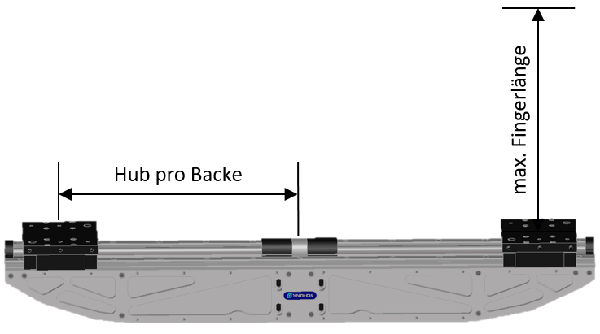

Example of gripping force calculation in frictional griping:

$$gripping force=\frac{workpiece weight*\left(gravity+ext. Acceleration\right)}{friction coefficent}*saftey factor$$
$$Greifkraft=\frac{28,5 kg*\left(\begin{aligned}9,81\frac{m}{s^{2}}+3\frac{m}{s^{2}}\end{aligned}\right)}{0,1}*2$$
$$Greifkraft=7301,7 N(→BG 7500 N)$$

3. Drive version
Synchronous | one drive motor - synchronized jaw movement
Asynchronous | two drive motors - asynchronous jaw movement (only possible from stroke 150mm per jaw)
4. Motor interface (Which drive motor should be used?)
Motor manufacturer |  | Only motor mounting kit  (motor mounting by customer) |  | Incl. motor assembly  (motor provision by customer) | Incl. motor assembly  (motor from SCHUNK)
Preferred drive motors (drive motor type see special data sheet)
BOSCH
SIEMENS
Further motors (partly with technical restrictions - see special data sheet)
Fanuc
KUKA
SEW
Unkown motor (need technical clarification)
Unkown motor:

 |  | Motor type:
5. Mechanical interface to the robot / handling system
Without adapter
With adapter (free flange pattern)*
* Need technical clarification / Please provide 3D model or drawing of the flange.
6. Options
Cover plates (ADB)
Yes
No
Weight optimization (GOA)
Yes
No

7. General description of the application (if necessary with sketches, etc.)
Please describe the task in detail.
8. Workpiece
Weight workpiece: |  |  | [kg]
Material of the workpiece at the contact point |  |  |  | Steel |  | Aluminium |  | Rubber |  | not specified
Clamping marks allowed |  |  |  | yes |  |  |  | no
coefficient of friction (suggested based on their choice of material, e.g. steel on steel 0.1) |  |  |  |  |  |  |  |  |  |  | 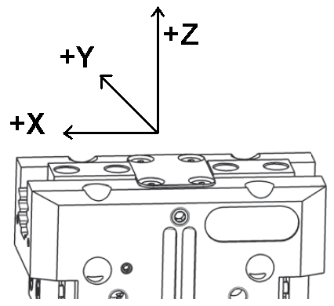
Gripping Ø or gripping dimension during gripping |  |  | [mm]
Center of gravity distance from the top edge of the gripper housing: [mm] in X: in Y: in Z:
Type of gripping |  |  |  |  | form-fit gripping gripping by friction
9. Application data
Mounting position gripper |  | vertical (hanging) |  |  | horizontal
 |  |  |  |  | +/- X - direction |  | +/- Y - direction |  | +/- Z - direction
Kind of force | Acceleration of the gripper [m/s²]
Kind of force | Additional working force s [N]

