Checklist ORG 85

[Company]
[Customer number]
[Contact person]
[Street]
[ZIP,City]
[Country]

[select the date]

[Project]



Application data

Please enter all values into the blue fields.

Pressure: | [Pressure] bar

Assembly: | Choose the option

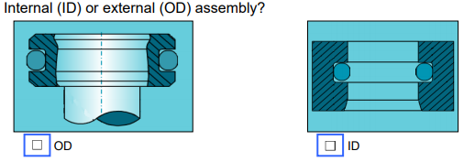

Diameter (d1): | [enter d1] mm

Diameter (d2): | [enter d2] mm

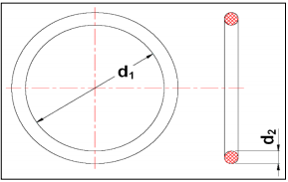

Relation vsd (only for ID): | [enter vsd ]

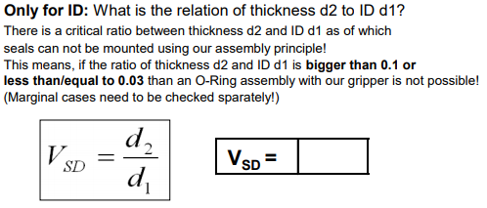
Assembly depth: | [Assembly depth] mm

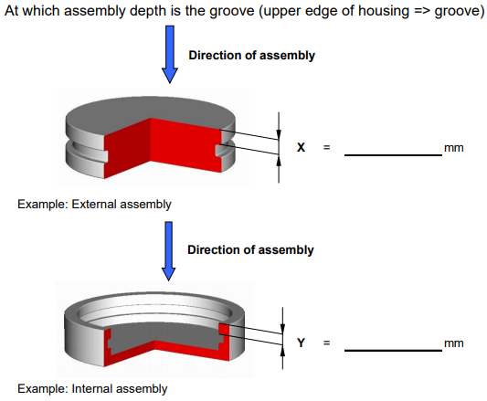

Seal: | [Choose the seal]

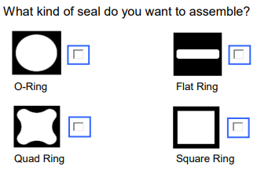

Material of the O-Ring: | [Material]

Shore hardness: | [Shore hardness]

---> e.g. NBR 70 Shore, Viton 80 Shore etc.

Diameter of the Workpiece: | [OD Assembly: D-Shaft & D-Recess OD]  [ID Assembly: D-Hole ID & D-Recess ID]

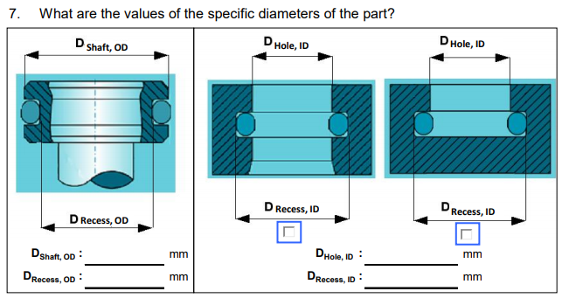

Conditions of assembly: | [Condition of the seal]

Condition of the seal while the assembly.
---> e.g. dry, lubricated, etc.

Handing over / feeding: | [ Choose the Handing over / feeding ]

---> What is the position of the seal (round or oval) ?

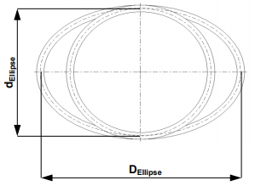

Monitoring with proximity switches : | [Choose an option]

---> Do you want to monitor the status/position of the gripper ?

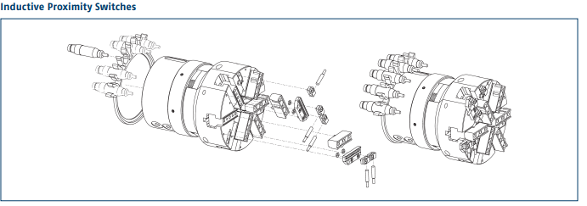

Please note:
If you need a test at SCHUNK to validate your application, please send at least 3 seals and the workpiece to the following address:
Please consult with an employee from the pneumatic sales department before shipping.

SCHUNK GmbH & Co. KG
Mr./Mrs. XXXXXXXX
Produktvertrieb Pneumatik
Spann- und Greiftechnik
Robert-Bosch-Straße 12
74336 Brackenheim

